**INSTITUTIONAL PROGRAM REVIEW 2009-10**

**Program Efficacy Phase, Spring, 2010**

**Purpose of Institutional Program Review**

Welcome to the Program Efficacy phase of the San Bernardino Valley College Program Review process.  Program Review is a systematic process for evaluating programs and services annually.  The major goal of the Program Review Committee is to evaluate the effectiveness of programs, and to make informed decisions about budget and other campus priorities.

The Institutional Program Review Committee is authorized by the Academic Senate to develop and monitor the college Program Review process, receive unit plans, utilize assessments as needed to evaluate programs, recommend program status to the college president, identify the need for faculty and instructional equipment, and interface with other college committees to ensure institutional priorities are met.

The purpose of Program Review is to:

❑  Provide a full examination of how effectively programs and services are meeting departmental, divisional, and institutional goals

❑  Aid in short-range planning and decision-making

❑  Improve performance, services, and programs

❑  Contribute to long-range planning

❑  Contribute information and recommendations to other college processes, as appropriate

❑  Serve as the campus’ conduit for decision-making by forwarding information to or requesting information from appropriate committees

Our Program Review process is two-fold.  It includes an annual campus-wide needs assessment in the fall, and an in-depth review of each program every three years that we call the Program Efficacy phase.  Instructional programs are evaluated the year after content review, and every three years thereafter, and other programs are placed on a three-year cycle by the appropriate Vice President.

An efficacy team of two disinterested committee members will meeting with you to carefully review and discuss your document.  You will receive detailed feedback regarding the degree to which your program is perceived to meet institutional goals.  The rubric that the team will use to evaluate your program is included with this e-mail

When you are writing your program evaluation, you may contact efficacy team assigned to review your department or your division representatives for feedback and input.  The list of readers is being sent to you with these forms as a separate attachment.

Forms are due back to the Committee Chairs, Efficacy Team and Division Dean by March 22, 2010.

It is the writer’s responsibility to be sure the Committee receives the forms on time.

In response to campus wide feedback that program review be a more interactive process, the committee will pilot a program efficacy that includes a review team who will interviews and/or tour a program area during the efficacy process. Another campus concern focused on the duplication of information required for campus reports. The pilot will incorporate the Educational Master Plan One-Page Summary (EMP Summary) and strive to reduce duplication of information while maintaining a high quality efficacy process. More details on the pilot can be found in the attached file.

**Program Efficacy, Spring 2010**

Complete and attach this cover sheet as the first page of your report.

**Program Being Evaluated**

|  |
| --- |
| Diesel |

**Name of Department:**

|  |
| --- |
| Diesel |

**Name of Division**

|  |
| --- |
| Applied Technology, Transportation and Culinary Arts |

**Name of Person Preparing this Report                                                  Extension**

|  |
| --- |
| Kevin Kammer |
| 8503 |

**Name of Department Members Consulted**

|  |
| --- |
| Dan Hook. |

**Name of Efficacy Team**

|  |
| --- |
| Sheri Lillard Ext. 8646; Celia Huston Ext. 8574 |

**Program Review Committee Representatives**

|  |
| --- |
| Guy Hinrichs; Richard Jaramillo |

|  |  |  |
| --- | --- | --- |
| **Work Flow** | **Due Date** | **Date Submitted** |
| Date of initial meeting with department 3/4/2010 | April 1, 2010 | April 1, 2010 |
| Final draft sent to the dean |  | April 1, 2010 |
| Report submitted to Program Review Team | Click here to enter text. | Click here to enter text. |
| Meeting with Review Team | Click here to enter text. | Click here to enter text. |

**Staffing**

List the number of full and part-time employees in your area.

|  |  |  |  |
| --- | --- | --- | --- |
| **Classification** | **Number Full-Time** | **Number Part-time, Contract** | **Number adjunct, short-term, hourly** |
| Managers | 1 | 0 | 0. |
| Faculty | 1 | 4 | 0. |
| Classified Staff | 0 | 0 | 0 |
| **Total** | 2 | 4 | 0 |

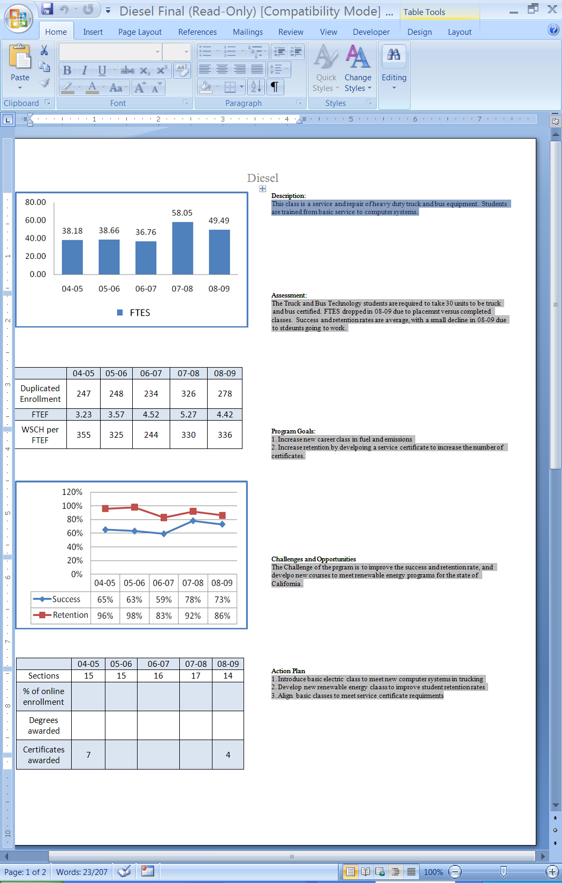

**Part I.  Questions Related to Strategic Initiative: Access**

Use the demographic data provided to describe how well you are providing access to your program by answering the questions below.

|  |  |  |  |
| --- | --- | --- | --- |
| **Gender** | **Frequency** | **Dept. Pct.** | **Campus Pct.** |
| Female | 52 | 4.0% | 58.5% |
| Male | 1244 | 94.5% | 40.5% |
| *Total | 1316 | 100.0% |  |

*\*Totals do not include respondents who did not identify gender.*

|  |  |  |  |
| --- | --- | --- | --- |
| **Ethnicity** | **Frequency** | **Dept. Pct.** | **Campus Pct.** |
| Blank | 10 | .8% | 1.47% |
| Asian | 42 | 3.2% | 4.58% |
| Black | 238 | 18.1% | 22.03% |
| Filipino | 22 | 1.7% | 1.93% |
| Hispanic | 646 | 49.1% | 39.85% |
| Nat Amer | 26 | 2.0% | .99% |
| Other | 12 | .9% | 1.18% |
| Pac Islander | 0 | 0% | .75% |
| White | 264 | 20.1% | 24.55% |
| X-undeclared | 56 | 4.35 | 3.17% |
| Total | 1316 | 100.0% | 100.00% |

|  |  |  |  |
| --- | --- | --- | --- |
| **Disability** | **Frequency** | **Dept. Pct.** | **Campus Pct.** |
| Non-Disabled | 1302 | 98.9% | 95.5% |
| Disabled | 14 | 1.1% | 4.5% |
| Total | 1316 | 100.0% | 100% |

Does the program population reflect the college’s population?  Is this an issue of concern?  If not, why not? If so, what steps are you taking to address the issue?

|  |
| --- |
| In most areas the Diesel Department student population reflects the college’s diversity. One of the main differences is in gender percentage. The diesel program lends itself mainly to males due to the heavy lifting and more physically strenuous requirements of the program. The department has committed to recruiting females to the program with presentations at the local high schools, booths and recruitment activities at the Annual Route 66 Rendezvous, and through the American Historic Truck Society activities. These out reach and diversity promotion programs will be continued along with continuing exploration of similar community events and programs. New department brochures are being developed and a emphasis will be placed on graphic representation of women in these occupations. There is also a 10 percentage point difference in Hispanic enrollment when compared to the campus. This overage can be partially explained by students of this diversity tend to enroll in the diesel program as a cohort. There is also a 4% difference in black and white students; this can be explained by small class numbers and the effect of several students skewing the diversity numbers. The students with disabilities percentage are lower than the campus average since the nature of the program does not lend its self well to students with certain physical disabilities. |

**Pattern of Service**

How does the pattern of service and/or instruction provided by your department serve the needs of the community? Include as appropriate hours of operation/pattern of scheduling, alternate delivery methods, weekend instruction/service.

|  |
| --- |
| The diesel classes are offered week days in the morning and evening to accommodate the working student’s schedule. This offering works well with most of the students and supports industry demands. There is also a Saturday class that meets the need of students that are employed during the regular 5 day work week yet still seek education to further their career goals. |

**Part II: Questions Related to Strategic Initiative: Student Success**

Provide a brief analysis of the data and narrative from the program’s EMP Summary and discuss what it reveals about your program.

|  |
| --- |
| The data indicates that in the area of student success the program has overall seen a small but steady increase. There was a small decrease in 2008. This can be attributed to a decrease in offered sections. The current economic climate has increased our student’s financial issues, and as a result they realize the need to succeed and make additional effort to achieve student success. Another factor is that the instructors have learned to recognize at an early time period students that are at risk of failure and can undertake remedial action. The student retention level is a mixed message that showed several dips and increases. Students in this program tend to stay enrolled as long as it does not interfere with an employment opportunity. If the financial need is too great students will seek employment rather than completing a program or section and benefiting from its long term prospect of higher wages and continued employment. One of the goals of the department is to increase retention by insuring students are aware of the benefits of completing all sections of a diesel technology program. One method of working toward this goal can be accomplished by the instructors explaining the benefits of completing all sections of the program for an institutional certificate instead of one or two classes that can enable a student to find entry level employment. Requesting campus counselors to present to a class or cohort explaining the added benefits of completing a program will also be a method used to increase retention. |

**Supplemental Data**

Provide any additional information such as job market indicators, standards in the field or licensure rates that would help the committee to better understand how your program contributes to the success of your students.

|  |  |  |  |  |  |  |  |  |  |  |  |  |  |  |  |  |  |  |  |  |  |  |  |  |
| --- | --- | --- | --- | --- | --- | --- | --- | --- | --- | --- | --- | --- | --- | --- | --- | --- | --- | --- | --- | --- | --- | --- | --- | --- |
| The Diesel Technologies program is part of the Transportation Center located at 264 South Leland Norton Way in San Bernardino. The Center is located at San Bernardino International Airport formally known as Norton Air Force Base. For most people when we think of diesel engines the visualization of a large truck with a diesel engine and a trail of black, sooty smoke comes to mind. In reality this is only a very small segment of diesel powerplant applications and far from the truth on diesel engine emissions. Diesel engine technology is used in the largest reciprocating engines ever built that are used in container ships with individual pistons over 3 feet in diameter and engines that develop thousands of horsepower. They are also used in pumping stations for natural gas and oil as stationary power plants. Diesel engine technology can be found in train locomotives and in over the road 18 wheel trucks and the refrigeration units that provide the power for cooling of perishables transported around the nation. Advances in diesel engine manufacturing technology and computer control have enabled aircraft manufacturers to employ diesel engines in new modern aircraft designs. Diesel technology is used to power electrical generating powerplants, an example can be the small generator powerplants used to power our colleges temporary classrooms for a number of months, to large power plants that are used to provide power for entire communities. Computer-control, new injection technology, and emission control systems have eliminated the former smoky, dirty diesel engine. Regulatory requirements, state and federal, will ensure that diesel engine emission control technology is a growing trend for all operators. Our students train with some of the latest diesel engine technology, troubleshooting equipment, and computer-based training equipment available in the industry today. An example of this includes some of the latest generations of diesel powerplant and transmission technology as training aids and computer based electrical and electronic training simulators. This enables us to ensure that a student who graduates from our program is prepared to enter the industry knowledgeable and capable on current, cutting edge diesel engine technology.  The 2008 edition of the *Encyclopedia of Career and Vocational Guidance* states that, “Diesel mechanics enjoy good job security. Fluctuations in the economy have little effect on employment in this field”. Preliminary Data from the EIS report for Fall of 2009 indicate a retention rate for the program at 92%, which is a 6% increase over 08-09 retention rate.  This occupational cluster of transportation and warehouse related occupations (Diesel Mechanics included) has a projected growth of 12.15% from 2008-2013. Both the location quotient and competitive effect (shift share analysis) are positive indicating that a) this cluster is stronger in the Inland Empire than comparatively in the state, and b) this cluster is exporting services generating revenue for the region*. Center of Excellence, Kevin Fleming, District Office SBCCD*  Occupational Change Summary   |  |  |  |  |  |  | | --- | --- | --- | --- | --- | --- | | **Occupational Change Summary** Region | 2008 Jobs | 2013 Jobs | Change | % Change | 2007 Avg Hourly Earnings | | Regional Total | 135,705 | 152,200 | 16,495 | 12% | $16.64 | | State Total | 1,016,405 | 1,073,212 | 56,807 | 6% | $16.83 | | National Total | 9,408,423 | 9,927,422 | 518,999 | 6% | $16.01 |   San Bernardino & Riverside Counties (the Inland Empire) can expect to experience a 12% growth within the transportation and warehousing occupational cluster within the next 5 years; a growth rate that far exceeds the state’s average of 6%.  Adjusting for anticipated retirements and moderate turnover, this cluster with grow within the region an estimated 16,495 jobs. To put this figure in context, the region is expected to increase by 1,172 legal occupations, 3,652 Architecture and engineering occupations, 4,963 Registered Nurses, 15,868 retail salespersons, and 24,090 construction trade workers. The transportation and warehousing occupational cluster is significant within the Inland Empire. *Center of Excellence, Kevin Fleming, District Office SBCCD*  The data displayed in the graph above portrays growth rate for three different areas, the nation as a whole, the state of California, and the local Inland Empire region. The graph only displays two lines of data. This is due to the State and the National data is virtually identical on a graphic basis.  The diesel program is pursuing NATEF / ASE certification. This department’s full time instructor must maintain ASE certification. Also various CalOSHA and Hazardous Materials regulations must be complied with in the lab environment. . |

**Student Learning Outcomes**

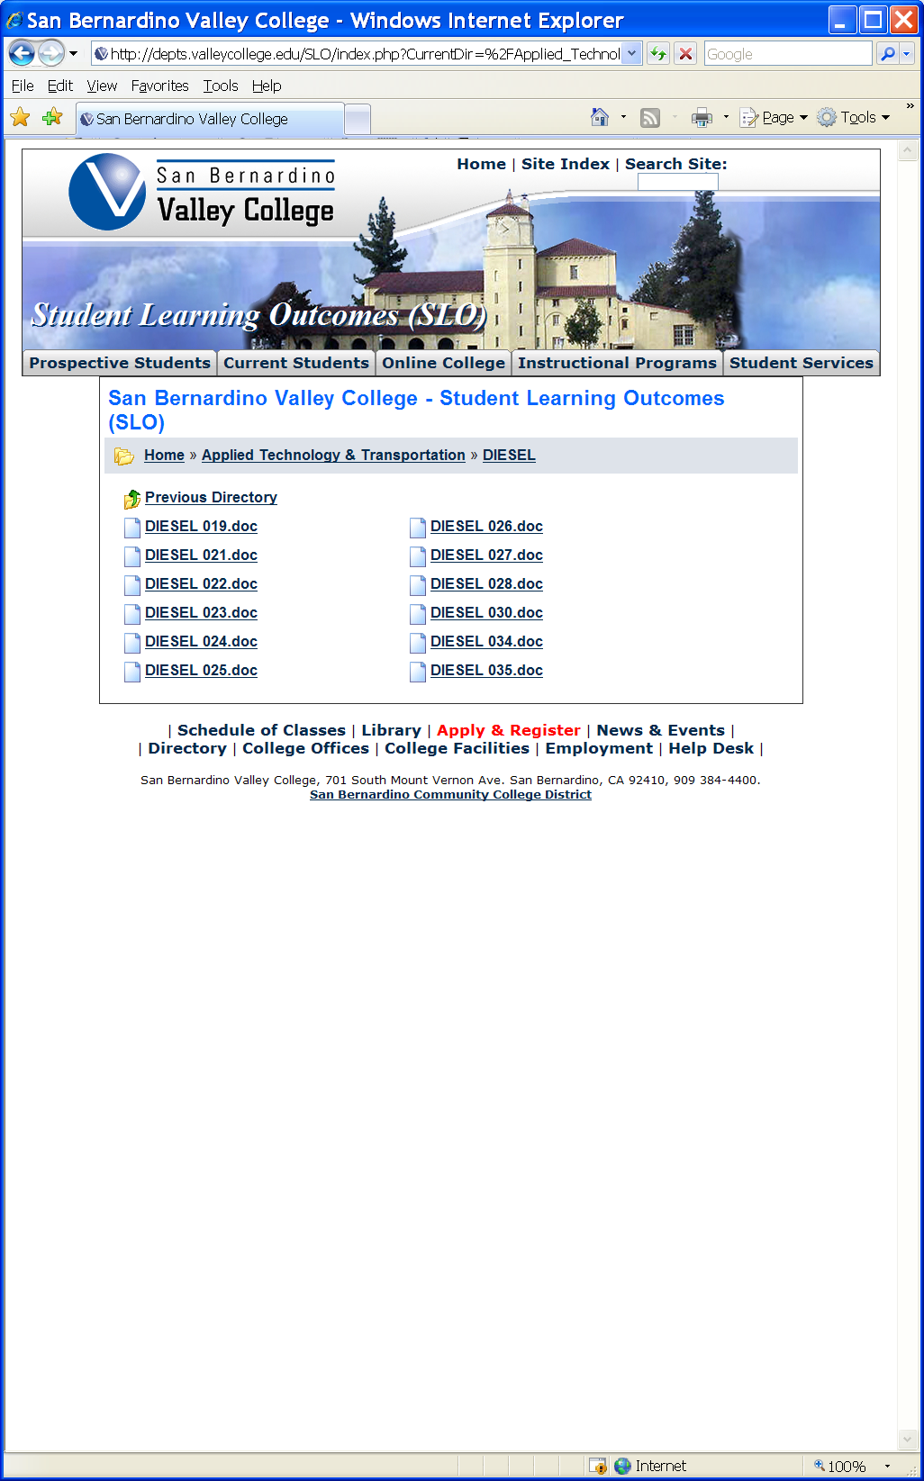

**The list above shows the courses that have SLOs on file with the Office of Instruction.**

If you have courses for which SLOs have not been developed, explain why.  What are your plans to remedy this?

|  |
| --- |
| **All courses have SLO’s** |

**Attach your three-year plan for assessing SLOs.**

What progress has the program made in its three-year plan? Have you implemented any program changes based on assessment results?

|  |  |  |  |  |  |  |  |  |  |  |  |  |  |  |  |  |  |  |  |  |  |  |  |  |  |  |  |  |  |  |  |  |  |  |  |  |
| --- | --- | --- | --- | --- | --- | --- | --- | --- | --- | --- | --- | --- | --- | --- | --- | --- | --- | --- | --- | --- | --- | --- | --- | --- | --- | --- | --- | --- | --- | --- | --- | --- | --- | --- | --- | --- |
| |  |  |  |  |  |  | | --- | --- | --- | --- | --- | --- | | **Transportation** | **SLOs Assessed** | **Total Courses** | **08/09** | **09/10** | **10/11** | | Rail | 0 | 4 | 2 | 1 | 1 | | Refrigeration | 0 | 14 | 5 | 5 | 4 | | Inspection | 0 | 12 | 4 | 4 | 4 | | Diesel | 0 | 10 | 4 | 3 | 3 | | Warehouse | 0 | 11 | 4 | 4 | 3 | |

No progress has been made toward assessing SLO’s. With personnel turnover in leadership positions in the Department very little discernable progress toward assessment and implementation of program changes based on assessment has been made. Diesel has developed a new three year rotation for assessment that will be implemented beginning this semester.

**New Three Year Plan for Assessing SLOs**

|  |  |  |  |  |  |
| --- | --- | --- | --- | --- | --- |
| **Spring 2010** | **Fall 2010** | **Spring 2011** | **Fall 2011** | **Spring 2012** | **Fall 2012** |
| Diesel 021 | Diesel 019 | Diesel 024 | Diesel 026 | Diesel 030 |  |
| Diesel 022 | Diesel 020 | Diesel 023 | Diesel 027 | Diesel 035 |  |
|  |  | Diesel 025 | Diesel 028 |  |  |
|  |  |  |  |  |  |
|  |  |  |  |  |  |

**Part III. Questions Related to Strategic Initiative: Institutional Effectiveness**

**Mission and Purpose**

What is the purpose of the program?

|  |
| --- |
| To provide the highest quality training and education to a broad diversity of students for employment in the industrial engine technology industry. This area of employment can include transportation, off-road, marine, stationary engines, and rail. |

How does this purpose relate to the college mission?

|  |
| --- |
| San Bernardino Valley College provides quality education and services that support a diverse community of learners.  The Diesel department’s program mirrors the mission of the college’s in aiming for the same goals of diversity, quality and educational accomplishment. |

**Productivity**

Provide additional analysis and explanation of the productivity data and narrative in the EMP Summary, if needed.

|  |
| --- |
| Overall FTES has increased from the 04-05 year to the 08-09 year by 11.0 percentage points which indicate a 30% increase. There has been a dip in 06-07 and a spike in 07-08. Projected FTES for the 09-10 year is at 51.30 from preliminary EIS data. There were fewer sections offered in 08-09 with FTES numbers returning to pre 08-09 norms. WSCH/FTE data has been fairly steady with a dip and increase working back toward 04-05 data. This can also be attributed to a decrease in offered sections. |

**Relevance and Currency, Articulation of Curriculum**

If applicable to your area, describe your curriculum by answering the following questions.

|  |  |  |  |  |
| --- | --- | --- | --- | --- |
| **Applied Technology, Transportation & Culinary Arts** | | | | |
| **Diesel** | | | | |
|  | **Course** | **Status** | **Last Content Review** | **Next Review Date** |
|  | DIESEL019 Truck and Bus Heavy-Duty Electrical Systems | Active | 11/10/2008 | 11/10/2014 |
|  | DIESEL020 Diesel Engines - Light Duty | Active | 01/26/2009 | 01/26/2015 |
|  | DIESEL020 Diesel Engines - Light Duty | Historical | 04/15/2002 | 04/15/2008 |
|  | DIESEL021 Diesel Engines - Heavy Duty | Historical | 04/15/2002 | 04/15/2008 |
|  | DIESEL021 Diesel Engines - Heavy Duty | Active | 12/04/2006 | 12/04/2012 |
|  | DIESEL022 Heavy-Duty Truck Brakes | Active | 12/04/2006 | 12/04/2012 |
|  | DIESEL022 Heavy-Duty Truck Brakes | Historical | 04/15/2002 | 04/15/2008 |
|  | DIESEL023 Heavy-Duty Truck Suspension and Steering | Historical | 04/15/2002 | 04/15/2008 |
|  | DIESEL023 Heavy-Duty Truck Suspension and Steering | Active | 12/04/2006 | 12/04/2012 |
|  | DIESEL024 Advanced Heavy Duty Diesel Engines | Historical | 11/15/2004 | 11/15/2010 |
|  | DIESEL024X3 Advanced Heavy-Duty Diesel Engines | Active | 11/10/2008 | 11/10/2014 |
|  | DIESEL025X3 Advanced Heavy-Duty Diesel Engines laboratory | Historical | 04/15/2000 | 04/15/2006 |
|  | DIESEL025X4 Advanced Heavy-Duty Diesel Engines Laboratory | Active | 12/11/2006 | 12/11/2012 |
|  | DIESEL026 Computer Controlled Diesel Engines | Historical | 11/15/2004 | 11/15/2010 |
|  | DIESEL026X3 Computer Controlled Diesel Engines | Active | 11/10/2008 | 11/10/2014 |
|  | DIESEL027X3 Computer Controlled Diesel Engines | Historical | 04/15/2000 | 04/15/2006 |
|  | DIESEL027X3 Computer Controlled Diesel Engines Laboratory | Active | 12/11/2006 | 12/11/2012 |
|  | DIESEL028 Heavy-Duty Truck Preventive Maintenance Service | Active | 12/04/2006 | 12/04/2012 |
|  | DIESEL028 Truck and Bus Preventive Maintenance Service | Historical | 04/15/2000 | 04/15/2006 |
|  | DIESEL030 Advance Heavy-Duty Truck Systems | Historical | 04/15/2002 | 04/15/2008 |
|  | DIESEL030 Advanced Heavy-Duty Truck Systems | Active | 12/04/2006 | 12/04/2012 |
|  | DIESEL034 Introduction to Heavy-Duty Compressed Natural Gas Vehicle Systems | Active | 11/15/2003 | 11/15/2009 |
|  | DIESEL034 Introduction to Heavy Duty Compressed Natural Gas Vehicle Systems | Historical | 11/15/2004 | 11/15/2010 |
|  | DIESEL035 Allison World Transmission | Historical | 11/15/2004 | 11/15/2010 |
|  | DIESEL035 Heavy-Duty Vehicle Automatic Transmissions | Active | 12/04/2006 | 12/04/2012 |

The Content Review Summary from Curricunet indicates the programs current curriculum status. If curriculum is out of date, explain the circumstances surrounding the error and plans to remedy the discrepancy.

As of December 2009 all classes have met their review date and are in compliance. The Diesel 034 is no longer being offered and status will be changed to historical in Curricunet.

Articulation

|  |  |  |
| --- | --- | --- |
| List Courses above 100 where articulation is not occurring | With CSU | With UC |
| No 100 series classes are offered no articulation is required | n/a | n/a |
| Click here to enter text. | Click here to enter text. | Click here to enter text. |
| Click here to enter text. | Click here to enter text. | Click here to enter text. |
| Click here to enter text. | Click here to enter text. | Click here to enter text. |

Describe your plan to articulate these classes.

|  |
| --- |
| No articulation agreement is required |

Currency

Review the last college catalogue data given below.

|  |  |
| --- | --- |
| **DIESEL**  DIVISION: Applied Technology,  Transportation and Culinary Arts  DIVISION DEAN: Gary Kelly, M.S.  FACULTY CHAIR: William Clarke, Ed.D.  Technical 108  (909) 384-8504  OTHER FACULTY: Daniel Hook, A.S.  DEPARTMENT SECRETARY: Amanda Moody  (909) 382-4079  DEPARTMENT OFFICE: 264 S. Leland Norton Way  Suite A120, San Bernardino  LIAISON COUNSELOR: Frank Dunn, M.A.  (909) 384-4404  Students working for certificates must have a basic  knowledge of arithmetic, reading and writing in order to  learn and work in the occupations they select.  **TRUCK AND BUS TECHNOLOGY**  **CERTIFICATE**  This certificate is designed to prepare students for entrylevel  positions repairing and maintaining diesel engines in  trucks, buses, locomotives, heavy vehicles, and mobile  heavy-duty equipment. Students working for certificates  must have a basic knowledge of arithmetic, reading and  writing in order to learn and work in the occupations they  select.  **REQUIRED COURSES: UNITS**  CIT 101 Introduction to Computer  Literacy  3  DIESEL 019 Truck and Bus Heavy-Duty  Electrical Systems  4  DIESEL 021 Diesel Engines - Heavy Duty 4  DIESEL 022 Heavy-Duty Truck Brakes 2  DIESEL 023 Heavy-Duty Truck Suspension  and Steering  2  DIESEL 024X3 Advanced Heavy-Duty Diesel  Engines  4  DIESEL 026X3 Computer Controlled Diesel  Engines  4  DIESEL 028 Heavy-Duty Truck Preventive  Maintenance Service  4  DIESEL 030 Advanced Heavy-Duty Truck  Systems  4  MATH 942 Arithmetic **or** 3  Eligibility for Math 952 as determined by the  SBVC assessment process  0 - 4  WELD023 Oxy-Acetylene Welding 3  WELD077X4 Continuous Wire Welding 1  **TOTAL UNITS: 35 - 39** | ***OF DIESEL*:**  **DIESEL 019**  **TRUCK AND BUS HEAVY-DUTY**  **ELECTRICAL SYSTEMS 4 UNITS**  ***PREREQUISITE: None.***  ***LECTURE: 3 contact hours per week and***  ***LABORATORY: 3 contact hours per week.***  This course covers basic principles of truck and bus  heavy-duty electricity and electronics systems. Detail  topics include batteries, charging, starting systems, and  the use of a digital multi-meter for analysis and diagnosis  of series, parallel, and series-parallel circuits.  *Associate Degree Applicable*  **DIESEL 020**  **DIESEL ENGINES – LIGHT DUTY 4 UNITS**  ***PREREQUISITE: None.***  ***LECTURE: 3 contact hours per week and***  ***LABORATORY: 3 contact hours per week.***  Theory and practical shop work in the repair, operation  and maintenance of light duty automotive diesel engines  and fuel injection systems. Course includes general  trouble-shooting and diagnostic testing. This course may  be used in preparation for the Automotive Service  Excellence (ASE) National Test.  *Associate Degree Applicable*  **DIESEL 021**  **DIESEL ENGINES-HEAVY DUTY 4 UNITS**  ***PREREQUISITE: None.***  ***LECTURE: 3 contact hours per week and***  ***LABORATORY: 3 contact hours per week.***  Theory and practical shop work in repair, operation, and  maintenance of heavy-duty industrial diesel engines and  fuel injection systems. Course includes general troubleshooting  and diagnostic testing. This course may be used  in preparation for the automotive Service Excellence  (ASE) National Test.  *Associate Degree Applicable*  **DIESEL 022**  **HEAVY-DUTY TRUCK BRAKES 2 UNITS**  ***PREREQUISITE: None.***  ***LECTURE: 1.5 contact hours per week and***  ***LABORATORY: 1.5 contact hours per week.***  Theory and practical shop work in the construction,  operation, and repair of heavy-duty truck brake systems  and components. Includes principles of hydraulic and  pneumatic brake systems, anti-lock, and computer  controlled braking systems used in today's modern heavyduty  diesel trucks and busses.  *Associate Degree Applicable* |
| **DIESEL 023**  **HEAVY-DUTY TRUCK SUSPENSION AND STEERING**  **2 UNITS**  ***PREREQUISITE: None.***  ***LECTURE: 1.5 contact hours per week and***  ***LABORATORY: 1.5 contact hours per week.***  Theory and practical shop work in the construction,  operation, and repair of heavy-duty truck suspension and  steering components. Includes principles of hydraulic and  pneumatic steering and suspension systems.  *Associate Degree Applicable*  **DIESEL 024x3**  **ADVANCED HEAVY-DUTY DIESEL ENGINES 4 UNITS**  ***PREREQUISITE: DIESEL 021.***  ***LECTURE: 3 contact hours per week and***  ***LABORATORY: 3 contact hours per week.***  This course covers theory and practical shop work in the  repair, operation, and maintenance of various heavy-duty  diesel engines. Topics include general troubleshooting  and diagnostic testing of engine components and systems  found in most engines from a variety of engine  manufacturers. This course is an advanced engine rebuild  class. This course may be taken three times. (*Formerly*  *DIESEL 024)*  *Associate Degree Applicable*  **COMPUTER CONTROLLED DIESEL ENGINES**  **4 UNITS**  ***PREREQUISITE: DIESEL 019.***  ***LECTURE: 3 contact hours per week and***  ***LABORATORY: 3 contact hours per week.***  This course covers theory and practical shop work in the  repair, operation, and maintenance of computer controlled  diesel engines. Topics include general troubleshooting  and diagnostics using assorted electronic and  computerized test equipment on operable computer  controlled diesel engines. This course may be taken three  times. *(Formerly DIESEL 026)*  *Associate Degree Applicable*  **DIESEL 028**  **HEAVY-DUTY TRUCK PREVENTIVE MAINTENANCE**  **SERVICE 4 UNITS**  ***PREREQUISITE: None.***  ***LECTURE: 3 contact hours per week and***  ***LABORATORY: 3 contact hours per week.***  Theory and practical shop work in maintenance and  preventive maintenance service of heavy-duty truck and  bus systems. Fundamentals of truck components and  systems are explained as students perform routine tasks.  Course is designed to provide students the needed skills  and knowledge to perform entry level labor tasks in the  heavy-duty truck service industry.  *Associate Degree Applicable* | **ADVANCED HEAVY-DUTY TRUCK SYSTEMS 4 UNITS**  ***PREREQUISITE: DIESEL 028.***  ***LECTURE: 3 contact hours per week and***  ***LABORATORY: 3 contact hours per week.***  Advanced level theory and practical shop work in  maintenance, air conditioning, ABS, computers, and  operations of the heavy-duty truck and bus systems.  Course is designed to provide students the needed skills  and knowledge to perform advanced level labor tasks in  the heavy-duty truck and bus service industry.  *Associate Degree Applicable*  **DIESEL 034**  **INTRODUCTION TO HEAVY-DUTY COMPRESSED**  **NATURAL GAS VEHICLE SYSTEMS 2 UNITS**  ***PREREQUISITE: DIESEL 026.***  ***LECTURE: 1.5 contact hours per week and***  ***LABORATORY: 1.5 contact hours per week.***  This course provides theory and hands-on experience in the  operation, service, inspection, and maintenance of  compressed natural gas (CNG) vehicle systems. This course  prepares students for the ASE Alternate Fuels Test (F-1).  *Associate Degree Applicable*  **DIESEL 035**  **HEAVY-DUTY VEHICLE AUTOMATIC**  **TRANSMISSIONS 2 UNITS**  ***PREREQUISITE: None***  ***LECTURE: 1.5 contact hours per week and***  ***LABORATORY: 1.5 contact hours per week.***  This course provides theory and hands on experience with  heavy and medium-duty automatic transmission operation,  construction, service and overhaul procedures. The  purpose of the class is to prepare the students to  successfully troubleshoot and repair heavy and mediumduty  transmissions.  *Associate Degree Applicable* |

Which courses are no longer being offered? (Include Course # and Title of the Course)

|  |
| --- |
| Diesel 034 Introduction to Heavy Duty Compressed Natural Gas Vehicle systems will not be offered. There is no longer a demand for this technology training. |
| New Department Chair, data will be updated in 2010/2011 Catalog |
| Click here to enter text. |
| Click here to enter text. |

**Planning**

What are the trends, external to the institution, impacting your student enrollment/service utilization? How will these trends impact program planning?

|  |
| --- |
| The economic slow down that has affected our nation and our area in particular has started to reverse with employers seeking to rehire laid-off workforce and continue hiring with new employees. This data is collected from the advisory committee that represents a broad cross section of the local industry. The emissions and fuels technology will experience rapid growth in industry due to regulatory requirements. Planning needs to recognize this growth and develop appropriate offerings to meet the need. The economic state of our service area dictates to some degree the employment trends, completion, and retention of students in the program. Planning needs to address keeping students in the program for completion of certificates offered by the program and to better qualify students for higher paying positions instead of “outing” the program at the first available employment opportunity. Communication plans need to be developed to address this issue. One approach we will develop is to survey the students to better determine their needs and issues preventing completion. Another plan is to communicate to the students through the institutions counselor program that completing an institutional certificate will benefit a student with a well rounded education that can benefit in a much wider field of employment and room for greater advancement in the workforce. The benefits of working toward a certificate that is offered by the institution instead of the instructional certificate offered by the instructors is another area that can be communicated to the students through statistics and data from the Labor Department. This will give a program graduate all the tools to succeed in the workforce with an approved institutional certificate with the full backing of the institution. A continuing trend for the industry is moving toward more computer controlled powerplants and vehicle systems. Planning to address this will entail our students are knowledgeable on basic computer skills and computer diagnostic skills. Continued addition of computer usage in the classroom and laboratory environments will ensure our students are qualified to enter the industry workforce. The certification on a state or county basis for emission system technicians required by government regulatory rule making will be a trend that the industry will adopt and our diesel program is planning a educational program to meet the need.. |

Accomplishments and Strengths

Referencing the narratives in the EMP Summary, provide any additional data or new information regarding the accomplishments of the program, if applicable. In what way does your planning address accomplishments and strengths in the program?

|  |
| --- |
| 90% of the students from this program are placed in the workforce. Our partnerships with members of our advisory committee who have hired our students have attributed to this employment success. Local trucking companies have contributed over 1 million dollars in equipment and industry support. Some of the local firms who have contributed toward the success of the program include, McLane Foods, Yellow Trucking, Thompson Trucking, Stater Bros, Farmer Trucking, Valley Power Systems, Cummins Inc., Gordon Trucking, Dalton Trucking, Inland Kenworth, Thompson Trucking, and Apex Bulk Commodities. Our facility has the some of the latest instructional and hands on technology available in the area. From the 04-05 year to FA 09 our success rate has increased form 65% to 89% which is a 37% increase. The 028 & 030 Diesel service classes were developed through a process of planning and consultation with our Transportation Advisory Committee. These classes are helping to meet specific needs in the local transportation industry. The partnerships developed with our Advisory Committee members have led to the development of the Service Technician Certificate. Planning and partnerships have enable this program to procure state of the art diagnostic and troubleshooting equipment and technology as previously noted in the supplemental data. |

Weaknesses

Referencing the narratives in the EMP Summary, provide any additional data or new information regarding planning for the program. In what way does your planning address trends and weaknesses in the program?

|  |
| --- |
| The Diesel program continually has difficulty in locating qualified part time and full time faculty. Plans are in place to recruit additional faculty and partner with the Logistics Training Consortium of Southern California whereby schools plan to share adjunct faculty in a cooperative manner and thus increase overall regional training capacity. The program is also in need of a Technical Assistant to support the Tool Room and provide additional laboratory safety/instructional aid. Working with the data collection department on campus we can strive to have the instructor issued certificates credited to student and department success. With this supplemental data available a more accurate picture off student success can be ascertained and a more accurate numbers for certificate issued is also available. |

**V. Questions Related to Strategic Initiative: Technology, Campus Climate and Partnerships.**

Describe how your program has addressed the strategic initiatives of technology, campus climate and/or partnerships.

|  |
| --- |
| The Diesel program has developed and employed the latest technology available in the transportation industry for service and maintenance training in the classroom. This enables our graduates to enter the workforce with the latest technology training available. This technology is available due to a close affiliation with the members of our advisory committee partnership who take a leadership role in helping us develop program that provide a properly trained workforce to meet industry needs. All instructors are factory trained and work in the Industry. As a result of this training the classes are updated every two years to keep the classes current and relevant to the industry and the latest technology is incorporated in our instruction. The campus reputation is being enhanced by 90% of our students entering the workforce. These students are trained and prepared and are able to make an immediate contribution to the community. |